Create Autonomous Exadata VM Cluster with ORM Stack

Contents

1. Introduction 1
2. Workflow diagram to deploy the stack 1
3. Create stack for Autonomous Exadata VM Cluster 2
4. Plan the Job 5

Introduction
An Autonomous Exadata VM Cluster resource provides the link between the Exadata Infrastructure resource and the Autonomous Container Database resources in your deployment. It is a set of symmetrical VMs (virtual machines) across all compute nodes of the underlying Exadata Infrastructure resource.

Workflow diagram to deploy the stack

Below diagram shows how the Terraform Artifact are applied in the OCI. While creating a ORM stack, using terraform deliverables Init, Plan and Apply is the flow to provision the resource in the OCI. We can have the deliverables in any of below.
- GitLab/GitHub Repo
- Bitbucket
- Can be in folder/.zip in the local disk
- Object Storage Bucket
- Can be in compartment
- Oracle provided Template


Create stack for Autonomous Exadata VM Cluster

Go to OCI Console Developer Services Resource Manager Stacks select the compartment Create Stack

My Configuration Folder Browse Select the “Autonomous Exadata VM Cluster” folder that contains the artifacts Upload

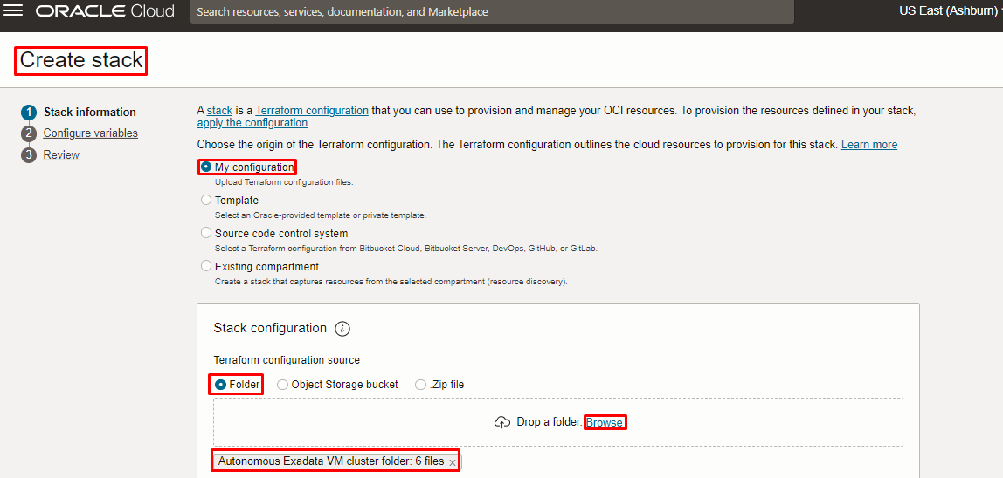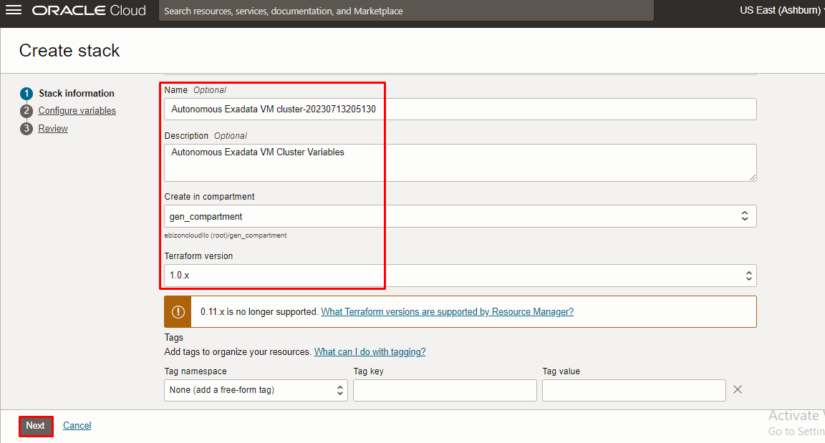

Click “NEXT”

Select the parameters as per the below screen,

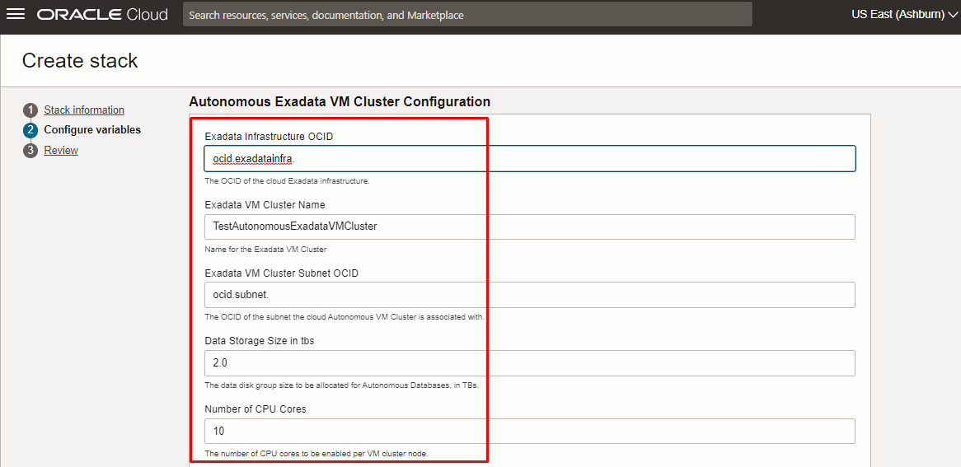
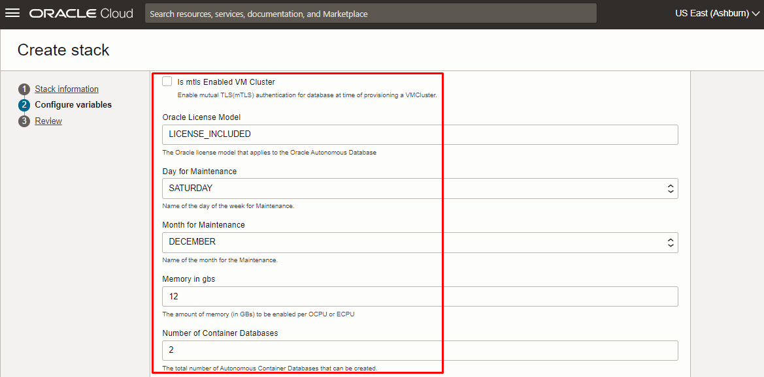
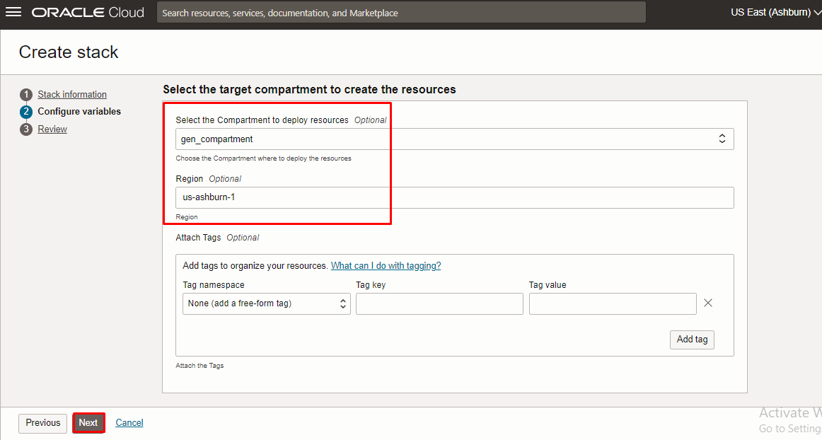

Note: select the right compartment to apply the stack in the OCI

Click “NEXT” Click “CREATE”

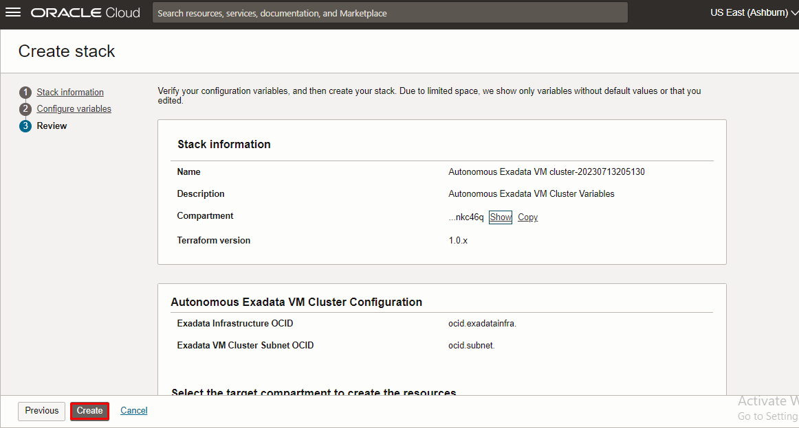

Plan the Job

Click the “Plan”

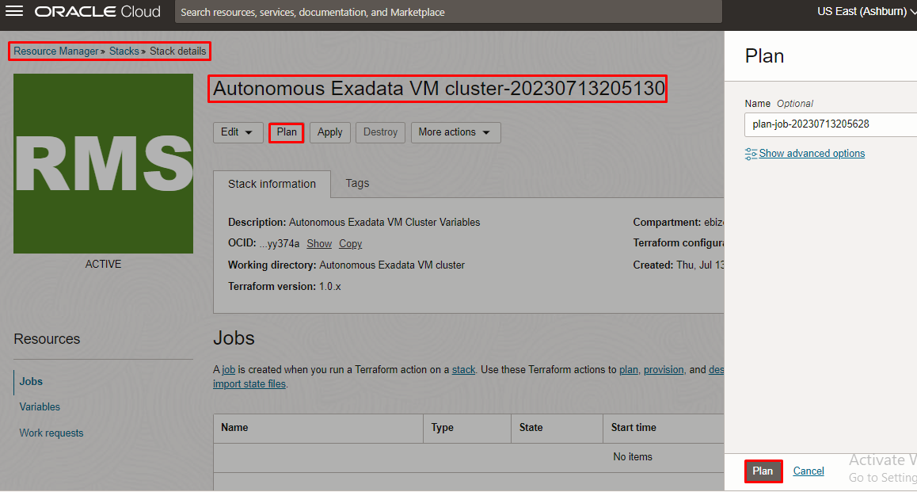

Verify the Plan is successful.

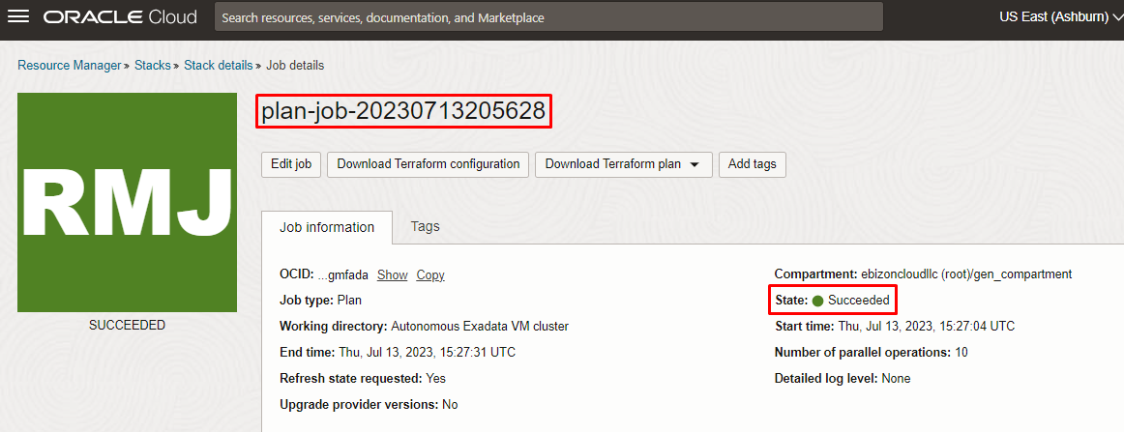
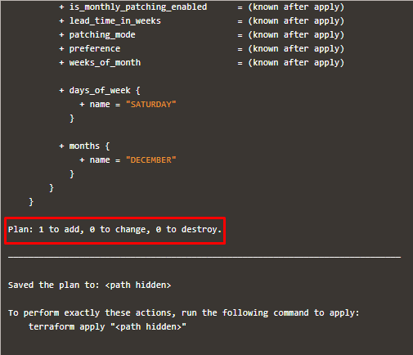

# END #

